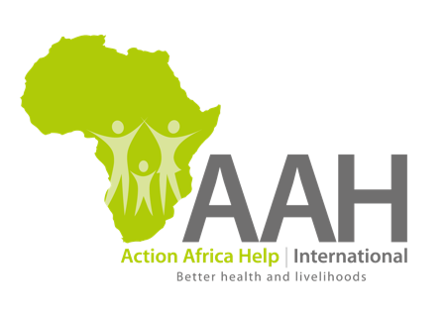

CONSULTANCY OPENING

2D ANIMATION – ABOUT AAH-I

Action Africa Help International (AAH-I) is a regional African-led non-governmental organization that supports livelihood-challenged communities in East and Southern Africa to sustainably improve their well-being and standard of living. With Country Programmes in South Sudan, Kenya, Somalia, Uganda, Zambia and recently in Ethiopia, AAH-I has over 30 years’ experience working with communities in conflict and post-conflict situations, including refugees, internally displaced people and host communities. More recently AAH-I has expanded its activities to work with other marginalized communities, including pastoralists and people living in informal urban settlements.

We are recruiting a consultant/consultancy firm to produce a 2-minute 2D animation of the AAH-I vision, mission and core values and impact numbers to date. The final product will incorporate existing video footage of AAH-I work in the various countries we work in. Depending on your concept, include any voice-over, sound track and sound effects costs.
Application Instructions
AAH-I invites eligible firms and individual consultants to indicate their interest for this assignment. Applicants must share links of three similar projects successfully completed.

Applicants must provide the following:
- Copies of Incorporation/Registration (where applicable)
- Copy of Pin\tax Certificate
- Tax Compliance Certificate
- Updated CVs or company profiles (not more than 4 pages)
Interested applicants should send their technical and financial proposals to procurementhq@actionafricahelp.org on or before 12 February 2019.

